# ITEC 4200 Advanced Database Semester Project

Student Name:

Semester:

Name of Project:

Email:

Phone number:

**EXECUTIVE SUMMARY**

**Objective**

This database is designed to assist **Esports Competitive Gaming** to track information about teams, their players, and the games that they play.

**Goals**

Our goal with this database project is to provide a simple and organized method of storing and retrieving relevant data for the successful operation of Esports. In addition, we will create queries and reports that provide useful information about the teams, players, and games so that it can help in the company’s growth.

**Solution**

The solution is the creation of multiple database tables including the relationships between those tables. The tables consist of the following: ***Team***, ***Player***, ***Player-Game***, ***Game***, ***Game-Platform***, and ***Platform***. These tables represent the main entities of the application, and contain links that define the relationships between entities. Using these tables, we can create the queries and reports that will provide the necessary information. It will be implemented in using Oracle 11g Express.

**Benefits to Users**

The database will serve as a valuable tool for providing information in a fast, convenient, and reliable fashion. It will help to streamline operations, provide insights to trends, and help to identify customer preferences.

**Project Outline**

The project will contain the following major components:

* Schema Design
* Entity-Relationship Diagram
* Table Implementation
* Queries
* Reports

**Part II. Schema Design**

**TEAM** (TeamID, TeamName, TeamEst)

**PLAYER** (PlayerId, PlayerAlias, PlayerFirst, PlayerLast, PlayerBirth, PlayerCountry, TeamID)

FK TeamID 🡪 TEAM

**GAME** (GameID, GameName, GameRelease, GameGenre)

**PLATFORM** (PlatformID, PlatformName)

**PLAYER-GAME** (PlayerID, GameID)

FK PlayerID 🡪 PLAYER

FK GameID 🡪 GAME

**GAME-PLATFORM** (GameID, PlatformID)

FK GameID 🡪 GAME

FK PlatformID 🡪 PLATFORM

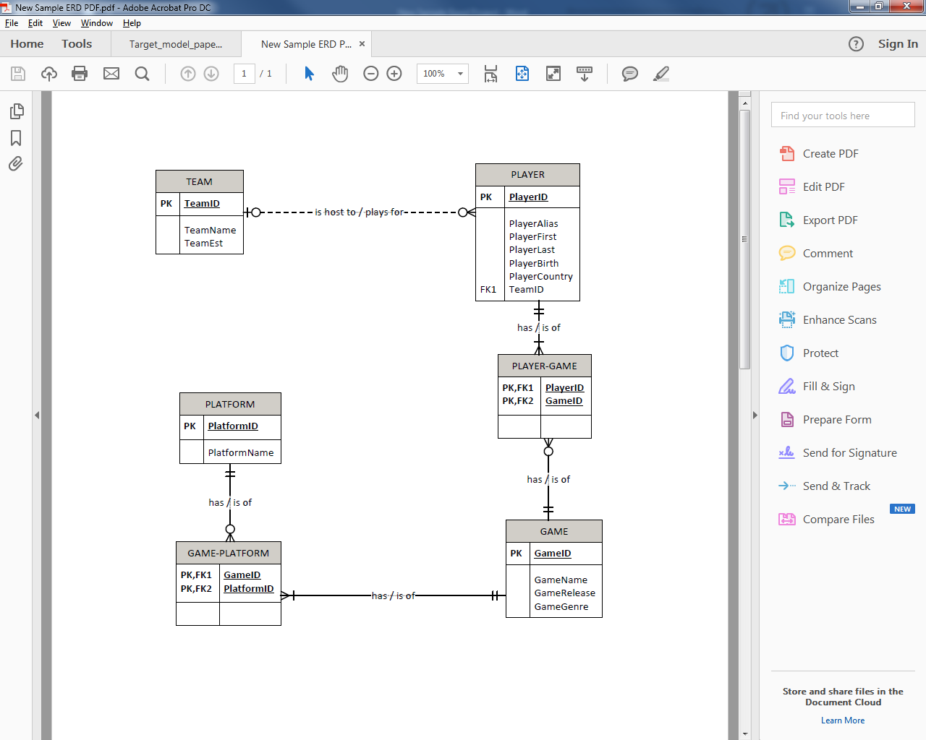

**Entity-Relationship Diagram**